From: https://www.washingtonpost.com/politics/stephen-k-bannon-architect-of-antiglobalist-policies-got-rich-as-a-global-capitalist/2017/03/31/47382082-0a8b-11e7-a15f-a58d4a988474_story.html?tid=pm_politics_pop&utm_term=.86035196af3c or
From: https://www.washingtonpost.com/politics/stephen-k-bannon-architect-of-antiglobalist-policies-got-rich-as-a-global-capitalist/2017/03/31/47382082-0a8b-11e7-a15f-a58d4a988474_story.html
Stephen K. Bannon, architect of anti-globalist policies, got rich as a global capitalist

By Michael Kranish and Renae Merle March 31 at 7:47 PM
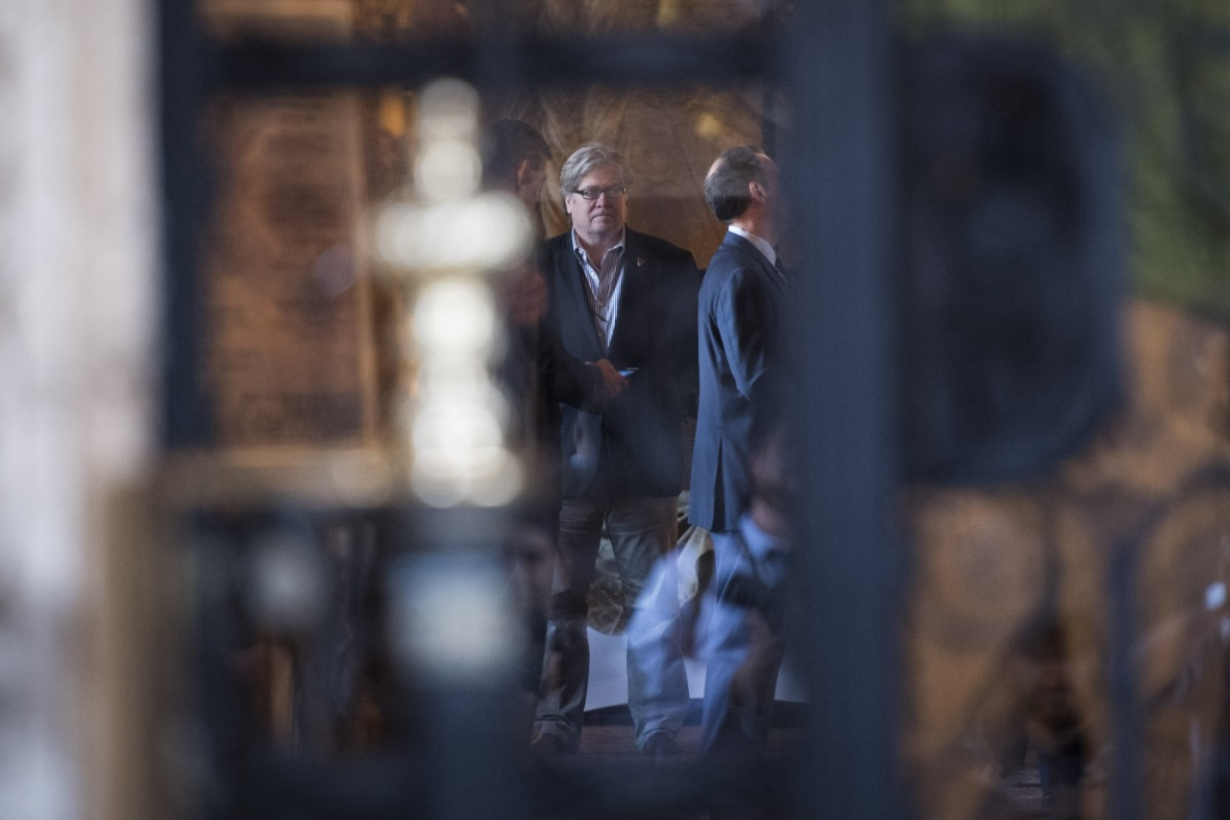
Stephen K. Bannon, chief strategist to President Trump, at the Mar-a-Lago Club in Palm Beach, Fla., in late 2016. ( Jabin Botsford / The Washington Post)
Stephen K. Bannon was running an investment banking company in Beverly Hills when his partner called with urgent news: a potential $10 billion deal was about to unfold in New York City involving a company they hoped to continue representing — and they didn’t want to be left out of the action.
Bannon, then in his mid-40s, told his business partner to meet him at the Los Angeles airport in an hour. Soon, they appeared at the Manhattan offices of PolyGram, a worldwide music company that they had previously represented in a film deal and now was for sale.
Before long, Bannon came up with an angle. He had represented Saudi Prince Alwaleed bin Talal, in a prior deal, and now he proffered the royal-family member, one of the world’s wealthiest Arabs, as a bidder. PolyGram was impressed and eventually paid Bannon a sizable fee for work on the overall deal.
“Those out of the room are out of the deal,” Bannon, now 63, said in an interview, recalling the 1998 meeting. “Once you make your way into the room, you stay.”
Years before Bannon became the architect of an anti-globalist revolution — working as chief strategist under President Trump to weaken free-trade deals, restrict immigration from a number of majority-Muslim nations and slam corporations that move jobs overseas — he made his fortune as the quintessential global capitalist.
An examination of Bannon’s career as an investment banker found that the Bannon of the 1980s and 1990s lived what looks like an alternate reality from the fiery populist of today who recently declared that “globalists gutted the American working class and created a middle class in Asia.”
With stints at Goldman Sachs and his own firm, Bannon was a creature of corporatism, wealth-building and international finance. His company received crucial financial backing from banks in Japan and France, and one of his key clients was the Saudi prince. It all was managed from the unlikely setting of an office steps away from the elite shopping district of Rodeo Drive.
In the Post’s online article there is A VIDEO “Meet Stephen Bannon, Trump's chief White House strategist” at this location. . Use a URL at the top, above, to watch it.
Here's what you need to know about the man who went from Breitbart News chairman to Donald Trump's campaign CEO before his appointment as chief White House strategist and senior counselor. (Jenny Starrs / The Washington Post)
[The video contains most of the hard, unsubstantiated criticism of Bannon and Trump I’ve come to expect from the WaPo. It’s hard to watch this, as opposed to reading the text of Kranish and Merle, and feel that you’ve read 2 parts of a single whole. –FNC]

Bannon, in two interviews for this report, acknowledged that he relied heavily on foreign financing in eight years of running a firm eventually known as Bannon & Co.
But he said the world in which he once operated, and made millions, had been changed by banks that now look out for themselves rather than their clients — and by multinational corporations that undermined the working class.
“We always were the financier of entrepreneurs, of which I’m a huge believer, and I’m not a believer in the corporatist mentality,” he said.
By his telling, this is the sentiment that led to the Bannon of today, the one who helped transform the far-right Breitbart News site into a platform for nationalism and then joined forces with Trump to upend much of Republican ideology.
Today, Bannon functions as a counterweight in the White House to an array of fellow Trump advisers who inhabit his former world, top officials from Goldman Sachs as well as other Wall Street veterans who embrace a more traditional brand of GOP policies such as free trade.
Yet in many respects, it is Bannon’s experience in their world that has positioned him for the struggle.
“I have lived all over the world, worked all over the world, financed with great partners all over the world,” Bannon said. “I’m not some angry guy sitting there. I think I have a pretty good feel for the direction of Europe, Asia and the United States, almost 40 years of experience.”

13 things you may not have known about Stephen K. Bannon
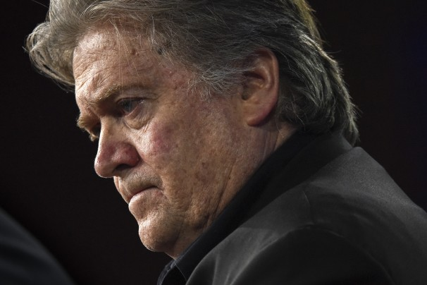
View Photos
Trump’s chief strategist served in the Navy, has a daughter in the Army and once referred to himself as a Leninist.

Bannon set out as a young man to make his fortune after serving seven years in the U.S. Navy.
He attended Harvard Business School, where he met recruiters from the investment banking firm of Goldman Sachs. He landed a summer job at the company’s New York City office and then a full-time position upon graduation. He arrived in 1985 to work on mergers and acquisitions.
Bannon “was unusual insofar as he was a bit older and he came from a military background, and that fact was core to his persona. . . . [He was] independent minded, with strong points of view,” said John L. Thornton, a former president of Goldman Sachs who steered the bank in an international direction, and whom Bannon considered as his mentor.
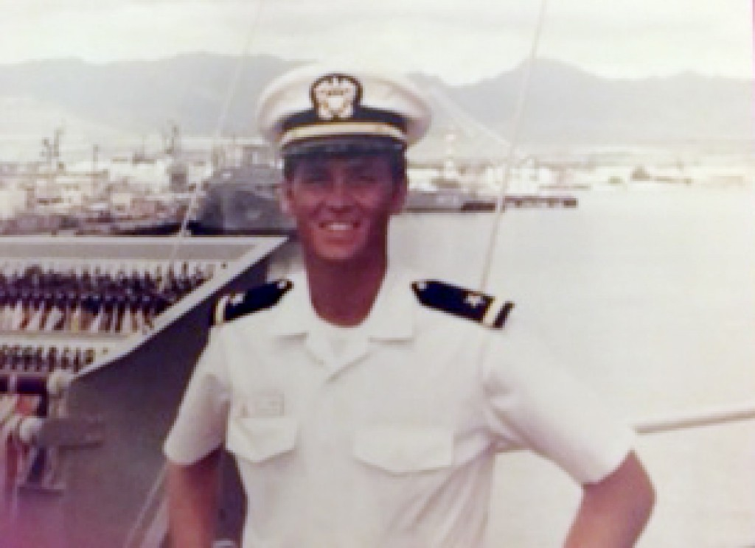
Bannon served in the U.S. Navy, in two deployments between 1978 and 1980. (Courtesy of the Bannon family)

Bannon’s main task during his first three years at Goldman Sachs was to respond to a boom in hostile takeovers. Goldman Sachs took the side of companies under attack from corporate raiders and leveraged buyout firms. Bannon had to come up with strategies to protect companies from unwanted suitors.
“A takeover is a very intense time. It is like you are going to battle,” said Scot Vorse, who attended Harvard with Bannon and worked with him at Goldman Sachs and Bannon & Co. “It was crazy. I worked many, many weeks in excess of 100 hours, and I know Steve did that often. At 10 p.m., you have 150 people walking around a floor with a piece of pizza and cup of coffee.”
After three years and a promotion to vice president — a title that was given to many Goldman Sachs employees — Bannon moved to the company’s Los Angeles office and was given the mission of drumming up business. He cold-called companies, looking to represent them as they considered splitting up or acquiring new businesses.
A turning point came in 1989, when Bannon said he persuaded Goldman Sachs to invest heavily in a fledgling company called Qualcomm, which was working on cellular telephone technology. Bannon said he did not receive extra compensation from the deal, which he said made a huge profit for Goldman Sachs. While he said he made about $450,000 annually at the time, that was a “night and day” difference, compared with what he might have made at a firm that paid him a huge fee for the deal. The philosophy of Goldman Sachs was to pay generously but not to provide the highest compensation until executives were made into partners, which could take years.
“It was a huge effort to get it done,” Bannon said. “I thought about it: ‘I will get all the grief if this deal doesn’t work out and none of the upside if it does well.’ . . . That investment was worth hundreds of millions of dollars.”
So in 1990, Bannon started his own firm.
He said the move was not about money. “It has always been about doing something I want to do and proving to myself I could do it,” he said. “Starting Bannon & Co. was a huge risk. People thought I was insane.”
Bannon stayed in California, he said, because he was focused on valuing intellectual property such as the movie industry — as opposed to the hard assets in the oil and gas business — and he believed there were big profits to be made as “the media and entertainment industry was just about to globalize.”
Bannon wanted to do big deals, but he didn’t have the financing. So he began to explore options overseas, including Japan, where investors were eager to get involved in Hollywood projects.
He struck a five-year deal with a major Japanese bank, Nissho Iwai, which he said supplied millions of dollars.
Relying on foreign money became a model for Bannon’s work. “Our forte was working with American companies to work with foreign investors,” Bannon said.
Bannon set up shop in Beverly Hills with Vorse, his former classmate and Goldman Sachs colleague. But much of his time was spent abroad in places such as Hong Kong and Singapore.
One of the company’s early successes involved a sale of television properties that wound up giving Bannon and his partners a huge payoff from future airings of what was then a little-known situation comedy: “Seinfeld.”
By 1996, with the Japanese deal having run its course, Bannon & Co. entered a partnership with Société Générale, a giant French investment company. The joint venture, which allowed Bannon to retain control over his company, was called Société Générale Bannon.
At the same time, Bannon’s global aspirations were solidified through a deal in which he got to know Prince Alwaleed bin Talal, who today is the world’s 45th wealthiest person, with a net worth of $18 billion, according to Forbes magazine. The prince declined to comment.
The prince, a nephew of the Saudi king, headed the United Saudi Commercial Bank and had major investments in companies including Euro Disney, Citibank and Saks Fifth Avenue. He made much of his fortune trading tens of millions of dollars on U.S. stock markets. He also made two purchases of properties that he has said “bailed out” Trump: the 1991 purchase of Trump’s yacht; and a $325 million purchase — in 1995, with a Singapore investor — of the Plaza Hotel.
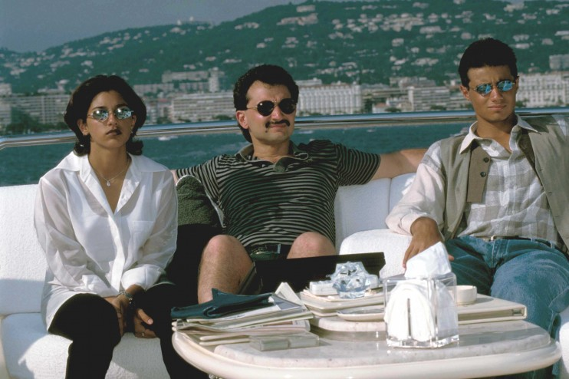
Billionaire Saudi Prince Alwaleed bin Talal, center, relaxes with his daughter Reem and son Kalid on his yacht, which he bought from President Trump. (Barry Iverson/The LIFE Images Collection/Getty Images)
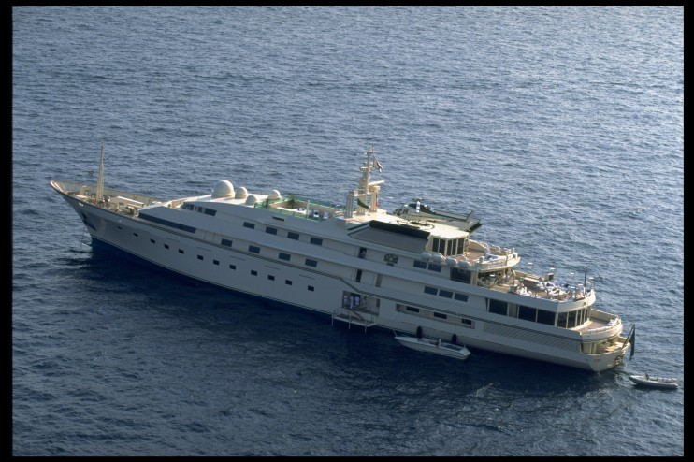
Prince Alwaleed bin Talal has said that his 1991 purchase of what now is the Kingdom 5-KR yacht “bailed out” President Trump. (Barry Iverson/The LIFE Images Collection/Getty Images)
Bannon said that starting in 1992, he met with the prince at least a dozen times, including in Beverly Hills and New York City, and possibly at the Cannes Film Festival.
The prince co-owned a firm with pop star Michael Jackson called Kingdom Entertainment. In 1996, Bannon advised the prince on Kingdom’s purchase of a 50 percent stake in Landmark Entertainment, a Hollywood-based company that produced music and television programs and developed theme parks. Bannon remained in touch with the prince, meeting him at the Four Seasons Hotel in Beverly Hills, in which the prince owned a stake, Vorse said. In addition, Vorse traveled to Riyadh to meet with the Saudi prince.
“Alwaleed was very savvy,” Bannon said. “He was a client for five or six years. . . . He had great ambitions. He wanted to be the Walt Disney of the Middle East.”
In 1998, the prince became an important part of one of Bannon’s biggest deals, when Vorse heard a rumor that a suitor wanted to buy PolyGram in what was expected to be a $10 billion deal.
“We show up in New York,” Vorse said. “We march into their executive suites. We say, ‘We are here to help; can we hang out in your conference room til you need us?’ It was almost like we were white-collar squatters. We moved into the conference room.”
A couple of possible bidders, including the Canadian conglomerate Seagram’s, were lined up when Bannon proposed the prince as an alternative.
When a PolyGram executive questioned Bannon’s relationship with the prince, Bannon responded that he should “call the prince’s main guy” to check it out, Vorse said. A short while later, the PolyGram president signaled to Bannon and Vorse with “the big thumbs-up,” Vorse said.
In the end, the prince didn’t buy PolyGram, but his work led him to be retained by the company, and Bannon said the prospect of an alternative bidder helped boost the price by 20 percent.
Bannon said he received “a big fee,” though he declined to disclose the amount.
As a result of this and other deals, Bannon’s company was ranked as the world’s fourth most valuable media investment bank, ahead of firms with thousands more employees, according to Vorse.
Soon, Bannon agreed to sell his company for an undisclosed amount to a subsidiary of his French partner, Société Générale, a move that eventually put an end to his role at the company he created.
While it is not possible to independently verify Bannon’s profits during this time, he said the deals and the sale of the company made him very wealthy. He said he had far exceeded whatever he was likely to have earned by staying with Goldman Sachs. During his 14 years in investment banking, Bannon was invariably described by friends as a country-club type of Republican, trim, athletic and movie-star handsome. A number of former colleagues said that they don’t recognize the Bannon of today, either in his rhetoric or disheveled appearance.
Bannon has said he was fundamentally changed by the impact of the 9/11 terrorist attacks and the 2008 financial crisis.
The crisis prompted Bannon to say that Wall Street no longer operated in the way he was taught, by working to build companies and watch out for a client’s interest. The financial crisis, he said, was caused by those whose main motivation was to make as much money as possible for oneself, a “financialization” of Wall Street that put bankers’ profits over those of everyday investors. “It was before all these quants and mathematicians really came to Wall Street,” Bannon said in a French documentary about Goldman Sachs.
He said he was further infuriated by the taxpayer bailouts of major banks, which were engineered by the former chief executive of Goldman Sachs, Henry M. Paulson Jr., who was President George W. Bush’s treasury secretary.
Bannon has also said that he took a hard turn to the right because his father, who worked for AT&T, lost money selling the company’s stock in the wake of the financial crisis.
Bannon began using some of his fortune to produce movies that reflected a darker worldview. His films, such as “Generation Zero,” portrayed the United States as sliding into a cultural and financial decline. Bannon channeled his anger into support for the tea party movement and, later, into pressing an anti-globalist message as chairman of Breitbart News.
Bannon has said Breitbart News is “the platform for the alt-right,” referring to a small movement that seeks a whites-only state. Bannon, however, has said he is not a white nationalist but a “strong American nationalist.” Bannon’s views eventually were embraced by Trump, who was an avid reader of Breitbart News and had been interviewed by Bannon on a radio program.
Trump hired Bannon in August 2016 as his campaign’s chief executive, and the former investment banker helped steer the self-described multibillionaire to the presidency with a populist message.
While Bannon shaped Trump’s agenda, his former client, Prince Alwaleed bin Talal, was aghast at Trump’s proposal to have a “total and complete and shutdown of Muslims entering the United States.” The prince said on Twitter — in which he owned a $1 billion stake — that Trump’s proposal was a “disgrace.” Trump tweeted back that he was a “dopey prince.”

Bannon said he has not talked with the prince in years, and he said that his views on Islam are misunderstood. “I don’t have any issue with Islam,” he said. “I have a problem with radical Islam.”
Trump’s victory changed the prince’s outlook, and the prince again took to Twitter, this time to congratulate the new president. That was just the beginning of an effort by the Saudis to court the new president, and they were rewarded with a March 14 meeting in the Oval Office with Trump and Saudi Deputy Crown Prince Mohammed bin Salman, a son of Saudi King Salman bin Abdul Aziz.
Bannon, whose principle for decades has been to be in the room when a deal is being made, was by Trump’s side during the meeting.
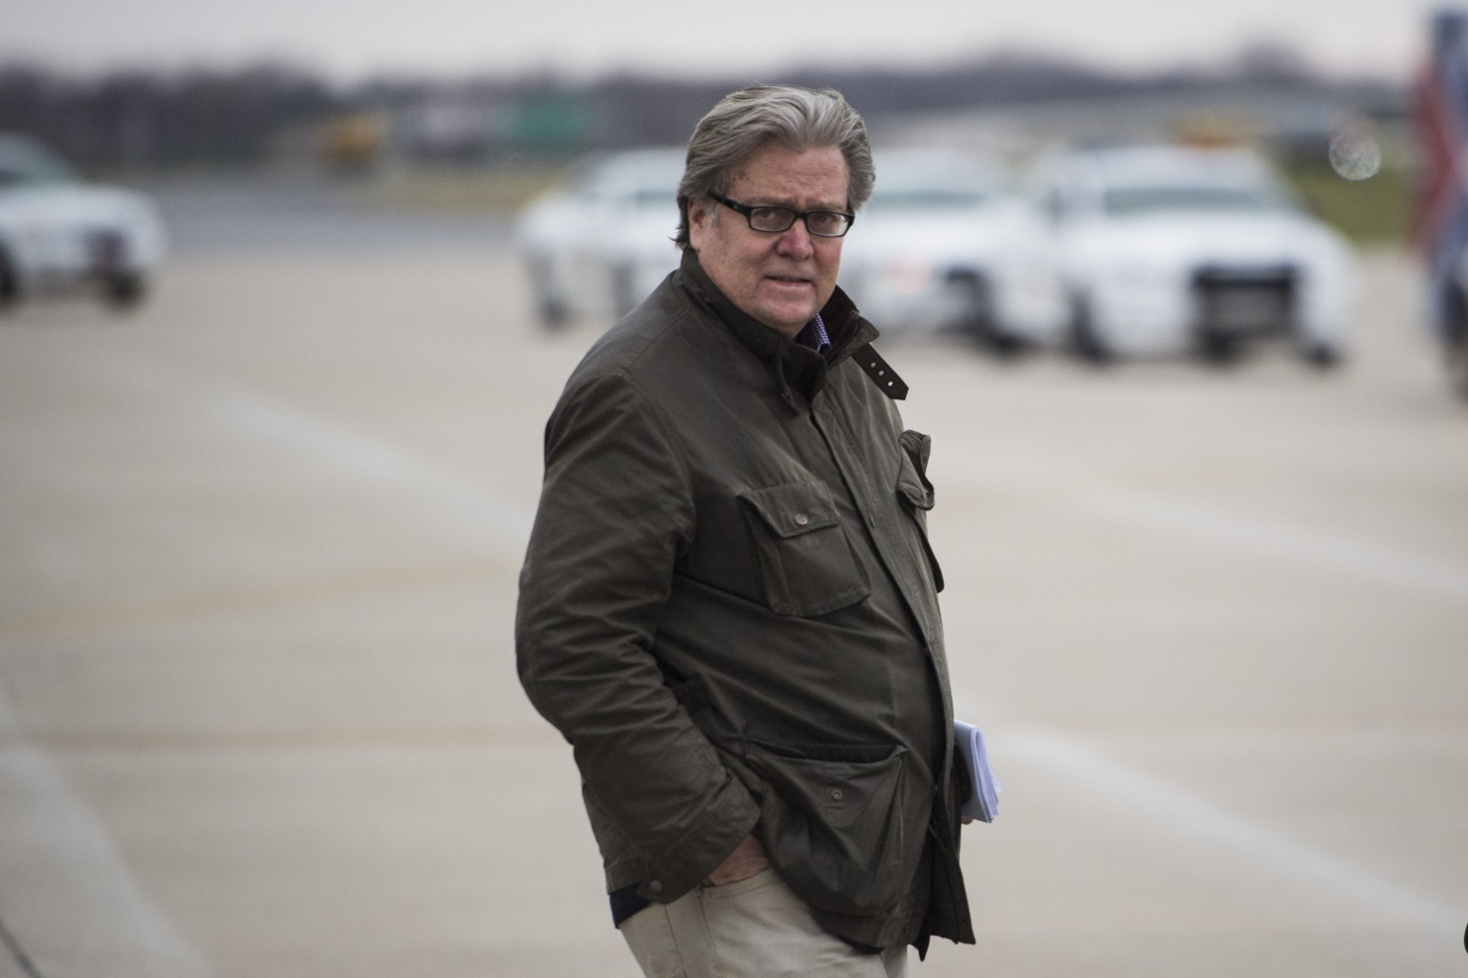
Bannon walks from then-President-elect Donald Trump’s plane on Dec. 1, 2016, in Indianapolis, on the way to their meeting with Carrier Corporation. Bannon’s business experience stretches back decades. (Jabin Botsford/The Washington Post)
Jean-Louis Magda contributed to this report.
846

Michael Kranish is a national political investigative reporter for The Washington Post. He is the co-author of The Post’s biography, "Trump Revealed," as well as biographies of John Kerry and Mitt Romney. A Washington-area native, he is also the author of "Flight from Monticello: Thomas Jefferson at War."
Follow @PostKranish
Renae Merle covers white collar crime and Wall Street for The Washington Post.
Follow @renaemerle

